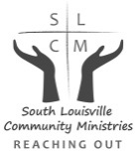
Please join us on
Tuesday, March 20, 2018

Families Helping Families Dinner

2018 Good Neighbor Award

Honorable Greg Fischer
Mayor of Louisville
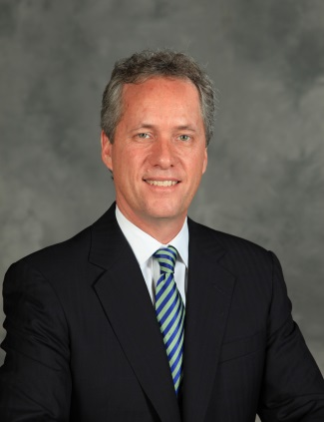

Musical Program
Iroquois High School Choral Group

Kosair Shrine Ballroom
4120 Bardstown Road

VIP Reception plus Dinner, Program & Awards 5:00-6:00pm $65
Dinner, Program & Awards 6:00-8:00pm $50
(Special Rates for Purchasing Table of 8)

For reservations and sponsorship opportunities, please call Joyce Whalin or
Yvette Livers at 502-361-7763

South Louisville Community Ministries Mission: To empower our neighbors in crisis to move toward stability and self- sufficiency.

Proudly sponsored by:
and

Please return to: South Louisville Community Ministries, 415 ½ West Ashland Avenue, 40214

$65.00 Per Person VIP Reception plus Dinner, Program & Awards
Number of Reservations _________________
$50.00 Per Person Dinner, Program & Awards
Number of Reservations _________________
(Special Rates for Purchasing Table of 8)
_____ I will attend event
_____Unable to attend
_____Enclosed donation to support work of SLCM

RESERVATIONS REQUESTED BY MARCH 7, 2018

Total amount enclosed $____________________.
Check or Cash only. Checks made payable to: South Louisville Community Ministries
Name___________________________________________________________
Address___________________________________________ZIP___________ Phone_____________________ Email ________________________________
All proceeds support South Louisville Community Ministries services

